Laboratory Tutorial 3-1: Entity Relationship Modelling

In this laboratory tutorial you will gain practical experience of:
- Reading and creating simple entity relationship models represented by the Unified Modelling Language (UML)
- Identifying entities and their relationships from system descriptions
- Specifying attributes and multiplicity constraints
*Note: We strongly suggest you do not start the Lab Quiz for this tutorial before you have all your answers ready.

Preamble
This tutorial will give you practical experience of reading and creating simple entity relationship (ER) models represented using the Unified Modelling Language (UML). Recall from the lectures that ER modelling is a key modelling technique employed during the conceptual design stage, which helps ensure that requirements and integrity constraints, specified earlier, are fully and effectively incorporated into the DB design. An ER model also provides a communication artefact that allows users to verify that the design will effectively support all of their requirements.
The understanding you gain here will prepare you for more challenging design work that you will attempt in later tutorials and in the summer examination.

Exercise 1: Entities and relationships
Q1: Complete the following definition of an entity: “A ___ of _______ with the same __________, which is identified by a user or organisation as having an ___________ existence”
Q2: What shape is used to represent an entity in an ER diagram?
Q3: Complete the following definition of a relationship: “A ___ of meaningful ____________ among ________”
Q4: How are relationships represented in an ER diagram?

Fill in the missing fields in the following StayHome ER diagrams, modifying the given entity/relationship names to follow naming conventions:
Q5: A distribution center stocks a DVD copy
_____?_____
____?____
___?___

Q6: A member receives a rental delivery
____?____

___?___

___?___

Q7: Identify the correct degree for each of the following entity relationships:
- A branch has staff
- Member of staff supervises other staff
- A solicitor manages a contract between a client and their supplier
- Member of staff registers a client’s account at a branch

Exercise 2: Attributes
Q8: Which of the following are examples of a composite (versus simple) attribute?
- year of DVD
- salary of Staff
- firstName of Staff
- address of Customer
- fullName of Customer

Q9: Which of the following might be examples of a multi-valued attribute?
- staffNo of Staff
- genre of DVD
- telNo of Customer
- dateOut of RentalDelivery

The following ER model describes the States relationship between Clients of a property letting company and the Preferences they make.
Client
clientNo {PK}
name
fName
lName
phone [1..3]
dateOfBirth
/age

Preference
prefType
maxRent

States

Q10: What is the maximum number of values that may be stored in the phone attribute of Client?
Q11: Which attribute is an example of a derived attribute?
Q12: Which attribute is an example of a composite attribute?
Q13: Which one of these is an example of a weak entity?

Exercise 3: Entity relationships and multiplicity
A multiplicity constraint is the number (or range) of possible occurrences of an entity that may relate to a single occurrence of another entity that is associated through a specified relationship. Multiplicity reflects the policies established by the organisation (or user) and constrains the way entities are related. For instance, a policy of StayHome might be that a Distribution Center must have one and only one manager. Hence the binary relationship Manages, between Staff and DistributionCenter is said to have a cardinality of one to one. In other words, it is only possible for (at most) one occurrence of Staff related to any one occurrence of DistributionCenter. Relationships can also have a cardinality of one-to-many, for instance a DVD title can have many copies of itself in stock (DVDCopy), or many-to-many, for instance an Actor can star in any number of movies and each movie can have any number of actors.
Relationships can be either optional or mandatory. In some relationships, an entity occurrence might be required to participate in a relationship (e.g. a DVDCopy must be stored in a DistributionCenter), whereas in others it might be optional (e.g. Staff Uses Car). Additionally, it is quite possible for the relationship to be optional on one side and mandatory on the other (e.g. not all bank customers would have a savings account, but all savings accounts must belong to a customer). This part of multiplicity is known as the participation constraint.
Multiplicity constraints are represented in ER model diagram by ranges, with participation on the left side of the range and cardinality on the right. The following table summarises different possible range specifications:

Taking the distribution centre manager example, the ER diagram below shows that a member of staff may or may not be the manager of one centre (0..1), whilst a centre must have exactly one employee as its manager (1..1). Take time to learn how to read multiplicities from an ER model diagram. Later you will need to not only determine the multiplicity ranges but also place them in the correct locations in the diagram.
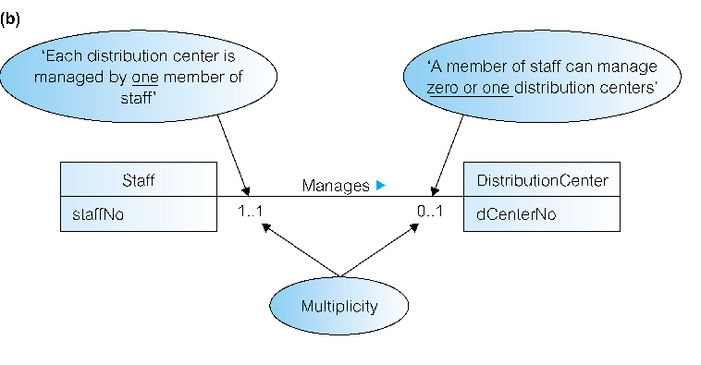

Q14: Express the multiplicity constraints, using UML notation (e.g. 1..1, 0..*), for each of the following examples:
- A Staff member has the option to be allocated one parking space
- A Member can optionally make up to 25 wishes
- A DistributionCenter has one or more staff
- A DVDCopy is stored in exactly one DistributionCenter
- A DVDCopy is rented zero or more times

The following system needs to be modelled as a simple database:
- A large organisation has several car parks, which are used by staff
- Each car park has a unique name, location, and capacity
- Each car park has parking spaces, which are uniquely identified using a space number
- Members of staff can optionally acquire exclusive use of one parking space. Each member of staff has a unique staff number, name, telephone extension number, and vehicle registration number

Q15: Which three of the following entities are required to model the car parking system described above?
- Staff
- CarPark
- Space
- Organisation
- Vehicle
Q16: Select from the following list, three attributes that are most likely to be members of the entities you identified above.
- location
- extensionTelNo
- registrationNo
- vehicleColour
- salary
- staffPosition

Q17: Below is an incomplete ER model diagram of the whole car parking system. Enter the correct names for all missing entity names (a, b and c) and attribute names (d, e, f and g).
[a]
[d] {PK}
name
extensionTelNo
[e]

[b]
spaceNo {PK}

Uses
Provides
[c]
[f] {PK}
location
[g]

0..1
[h]
[i]
1..1

Each Space can be used by up to one member of Staff and each Space is provided by one CarPark. These multiplicity ranges are already shown in the diagram as 0..1 and 1..1 respectively.
Q18: Two more multiplicity constraints need to be entered at locations [h] and [i]. Enter these ranges based on the information in the original descriptions. [h= 0..1; i= 1..*]

Summary and further work
In this tutorial you have begun to learn how to specify and represent entities and their relationships as ER diagrams. You have also learned how to identify attributes from requirements specifications, and how to categorise and represent different kinds of attributes with an ER model. Finally, you learned how specify multiplicity constraints for binary relationships. For further practice at ER modelling, you can attempt exercises 6.10 and 6.12 in Connolly et al.

Further Reading
Connolly, T., Begg, C. & Holowczak, R (2008) Business Database Systems (Chapter 6).

